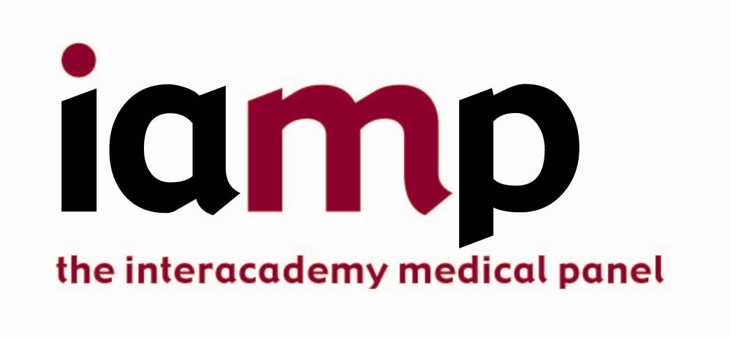

Invitation to the International Workshop on
“Integrated education in One Health”
Hungarian Academy of Sciences, Budapest, 5 June 2013
Registration Form
Please complete this form, and return it to the IAMP and FEAM Secretariats by emailing iamp@twas.org with cc: laurence.legros@feam.eu.com, at the earliest convenience,
but no later than 22 May 2013.

- Please provide your contact information (please print)
Salutation:  (please circle) | Dr. Mr. Mrs. Miss. Other (please insert):
First name:
(as on your passport)
Last name:
(as on your passport)
Professional Title:

Organisation:

Mailing address:
City: | Province: |  | Postal Code:
Country:

E-mail address:

Phone number (office): |  | Phone number (home):
Mobile phone number: |  | Fax number:

- Attendance Confirmation
- I will attend the Workshop on 5 June 2013.
- And I would like to submit material for dissemination via the Workshop’s WebPages or onsite.

