Nature of Urbanisation and Urban Policies in India

R. B. Bhagat

Professor and Head
Department of Migration and Urban Studies
International Institute for Population Sciences,
Mumbai-4000 88, India
E-mail: rbbhagat@iips.net

Paper to be presented in the Regional Workshop on “Managing Urbanization in Asia” organized by National Academy of Sciences of Sri Lanka, Colombo, 25-26 June, 2019.

Introduction:
The twentieth century witnessed a rapid shift of population from rural to urban areas in most of the countries of the world. A merely 13 per cent of the global population lived in urban areas in 1900, which increased to 29 per cent in 1950 and crossed the 50 percent mark (50.1 percent) in 2009 (U.N. 2009). In 2018, 55 percent of the world’s population has been residing in urban areas. However, the pattern of urbanization is found to be very unequal between the more developed and less developed world. More than 80 per cent of population of North America, Latin America and Caribbean lived in urban areas compared to 74 per cent in Europe and 68 per cent in Oceania. On the other hand, half of the population in Asia lives in urban area compared to 43 per cent in Africa (U.N. 2018).
In India only one-third of population lives in urban areas. In the decades after 1991 India has experienced an accelerated economic growth after the Central Government launched economic reforms in the country. The economic reforms aimed at loosening the control of the Govt and encouraged entrepreneurs to actively participate in India’s economic development. The economic growth reached to about 8 percent per annum during the first decade of the new millennium compared to just 3 percent growth in the early 1980s. This has also led a very spectacular change in the perception of the Central Government about urbanization. In Eleventh Five Year Plan (2007-2012), it is argued that urbanization should be seen as a positive factor in overall development. This change in the thinking is coincidental with the fact that urban sector presently contributes to about 65 percent of the GDP, and is also the product of the realization that an ambitious goal of 9 to10 percent growth in GDP fundamentally depends on making Indian cities much more livable, inclusive and competitive (Planning Commission 2008). The urban transition is considered as one of the major challenges which will require a massive expansion in urban infrastructure and services.
Under this backdrop, the results of the 2011 census on urban population growth assumes enormous significance in enhancing our understanding about the magnitude, growth and inter-state variations in the levels and tempo of urbanization in the country. This paper presents an assessment of the emerging pattern of urbanization, its spatial pattern and the components of urban growth namely contribution of natural increase, rural-urban classification of settlements and the contribution of rural to urban migration. It also throws light on some policy issues.
Definition of Urban

Historically, the process of urbanisation got intensified in the wake of industrial revolution in the western world which led to the expansion of infrastructure such as transport and communication and propelled increased rural to urban migration. The agglomeration of population, predominance of non-agricultural activities and better provision of social amenities including health and educational infrastructure emerged as distinguishing features of settlements following the industrialisation of agrarian economies (Bhagat 2005). In the contemporary times, however, the settlements have become increasingly complex. Thus, in the study of urbanisation it is pertinent to know how urban areas are defined because, from the demographic point of view, the level of urbanisation is measured in terms of percentage of population living in urban areas (Davis 1962). An area is classified as rural and urban depending upon various criteria such as population size, density, occupational composition and civic status. There is no thumb rule to divide rural and urban, and the practice is followed diversely across the countries of the world. For example, an UN study shows that 97 out of 228 countries use administrative criteria to make distinction between urban and rural; in 96 cases the criteria used to characterize urban include population size or population density. The economic characteristics were used to define urban areas only in 25 countries and 15 countries have applied the functional criteria like paved streets, water supply system, sewerage systems and electric lighting etc. Lastly in 22 cases no urban definition was available and in further 8 all the population was considered either urban or rural depending upon the circumstances (Zlotnik 2002). Thus, in the study of urbanisation at the global level, one should not lose sight of the definition of urban followed in each country and the changes therein in order to understand the urban dynamics appropriately.
In India during the British rule, urban area was defined as including every municipality of whatever size, every cantonment, all civil lines not included in municipal limits, and every other collection of houses permanently inhabited by not less than 5000 persons which is of an urban character though not under municipal government. This definition continued until 1961 census left the scope for state census superintendents to apply their judgments in declaring the settlements as urban. The latter aspect has been considerably reduced since 1961 census, which defined the urban on the basis of two important criteria namely: i) statutory administration and ii) economic and demographic aspects. The first one includes civic status of towns such as municipal corporations, municipality, cantonment board, notified area committee, etc., and the second comprises criteria like population size, density of population and percentage of work force in non-agricultural sector. The towns identified on the basis of former criteria are known as statutory or municipal towns and the towns defined on the basis of demographic and economic criteria are termed as census or non-municipal towns (Bhagat 2005).
The more specifically the criteria of defining urban as mentioned in the recent census report are as follows:
i) All places with a municipality, corporation, cantonment board or notified town area committee etc.
ii) All other places which satisfy the following criteria:
- Minimum population of 5000
- At least 75 % of male working population engaged in non-agricultural pursuits and
- A density of population of at least 400 persons per square km.

Besides, the directors of census operations in states/ union territories were allowed to include in consultation with the concerned state Governments, union territory administration and the census commissioner of India, some places having distinct urban characteristics as urban even if such places did not strictly satisfy all the criteria. The state governments decide about the civic status, while the Census of India applies the demographic and economic criteria in identifying towns at every ten years. These two criteria are applied independently by the two agencies. Thus in every census several new towns are added as well as declassified if they do not satisfy the above mentioned criteria. However, it is mentioned that India’s urban definition is male biased as it considers only male workforce employed in non-agricultural sector. But given the very low level of participation of women in non-agricultural sector, it is done so (Bhagat 2002). The definition of urban adopted since 1961 census remained fairly constant until 2011 Census except that since 1981 the economic activities like fishing, livestock, logging, plantations, orchards etc were excluded from the category of non-agricultural pursuits for computing the percentage of male workforce in non-agricultural sectors (Census of India 1991). This would have hardly any significant impact while comparing the urbanisation trend over time.
It will be worthwhile to mention the criteria of defining urban applied by some of the neighboring countries in order to understand the nature of urbanisation in India in a proper perspective. For example, in the neighbouring country of Nepal only size of population (more than 9000 population) is taken to declare a settlement as urban. Geographically Nepal is situated on mountainous terrain and economically it has low level of industrialization and development. On the other hand, the neighbours like Bangladesh, Sri Lanka and Pakistan apply administrative criteria to declare a settlement urban. Any settlement with municipal corporation, municipality, town committee and urban councils etc. are declared as urban (United Nations, 2006). While Bangladesh has much lower level of urbanization (27.6 per cent), Pakistan stands much higher (35.6 per cent) compared India (29.7 per cent) in 2009. It would be interesting to mention how urban population is defined in the world’s largest populous country-China with urban population of 46.1 per cent in 2009 (UN 2009). In China, the urban population lives within the jurisdiction of cities and towns, and rural population lives in counties. Cities are established with the approval of the central government and towns are classified based on population size as well the size of non-agricultural population under the township government. The non-agricultural population is ascertained based on household registration system maintained by local resident committees in towns and village committees in townships. There is no uniform rules followed by these committees in making distinction between non-agricultural and agricultural populations, nor are the rules transparent as the nonagricultural resident enjoy significant privileges in terms of access to apartments, jobs and subsidized food. In fact, the size of urban population in China very much depends upon how non-agricultural population is defined (State Statistical Bureau of China 1998), and the rural-urban classification is associated with differential privilege (Zhu 2001).
There exists a considerable difference in the way urban areas are defined in different countries. However, India’s definition of urban seems to be more stringent compared to other south Asian countries. It is because of this reason that India’s level of urbanization is much lower than Pakistan and several African countries.

Trend in Urbanisation
The Office of the Registrar General and Census Commissioner of India projected the urban population be 358 million for the year 2011, and estimated that urban population growth rate would decline from 2.75 percent per annum observed during 1991-2001 to 2.23 during 2001-2011 (Office of the Registrar General and Census Commissioner 2006). The urban experts also believed in the slowing down of India’s urbanisation because of its exclusionary nature and its inability to spur rural to urban migration (Kundu 2007; 2011). However, the 2011 Census shows some unexpected results.

According to 2011 Census, urban population grew to 377 million showing a growth rate of 2.76 percent per annum during 2001-2011 and the level of urbanisation at the country as a whole increased from 27.7 percent in 2001 to 31.1 percent in 2011- an increase of 3.3 percentage points during 2001-2011 compared to an increase of 2.1 percentage points during 1991-2001. This clearly reflects the the faster economic growth during 2000s in bringing out speedier urbanisation during 2001-2011.

Table 1 shows that India has about 79 million urban population in 1961 which constituted about 18 percent of the total population. The average growth rate of urban population was 2.32 percent during 1951-61 which accelerated up to 3.79 percent during 1971-81 i.e. the highest urban growth since independence. After 1981, the urban growth rate decelerated to 3.09 percent during 1981-91 and further declined to 2.75 during 1991-2001. However, the declining growth rate was slightly reversed during 2001-2011. The total addition to urban population was 91 million during 2001-2011- highest ever and for the first time urban population increment was higher than rural increment (90.5 million) since a uniform definition was followed since 1961.
It is worthwhile to mention that urban population growth alone cannot speed up urbanisation but more importantly if urbanisation has to occur, urban population growth rate needs to be higher than the rural population growth rate. Thus, it is the urban-rural population growth differential that is critical to the process of urbanisation. Table 2 shows that the urban-rural growth differentials increased from about 1 percent per annum during 1991-2001 to 1.60 percent per annum during 2001-2011. It is also evident from Table 2 that the rural population growth has declined much faster during 2001-2011 compared to earlier decades. It is worthwhile to mention that the urban-rural population growth differential is the product of the differential in natural increase between rural and urban areas (births-deaths), net rural-urban classification and net rural to urban migration. The urban-rural growth differentials in natural increase remained almost constant (4 per 1000 population) during 1991-2000 to 2001-20010. Therefore, it was the net rural-urban classification and net rural to urban migration that was responsible for higher urban-rural growth differential and speeding up urbanisation during 2001-2011. The exact contribution of different components of urban growth is presented in the sections to follow.

Table 1: Trends in Urbanisation in India, 1951-2011
 | Census year | Urban  population  (in million) | Per cent  urban | Annual exponential  urban growth rate (%)
 | 1961 | 78.94 | 17.97 | -
 | 1971 | 109.11 | 19.91 | 3.23
 | 1981 | 159.46 | 23.34 | 3.79
 | 1991 | 217.18 | 25.72 | 3.09
 | 2001 | 286.12 | 27.86 | 2.75
 | 2011 | 377.10 | 31.16 | 2.76
Notes: As the 1981 Census was not conducted in Assam, and 1991 Census
was not held in Jammu and Kashmir, the population of India includes their
projected figures.
Source: Census of India -respective censuses (www.censusindia.gov.in).

Table 2: Urban-Rural Population Growth Differentials, 1971-2011
(annual exponential growth rate in %)

Decade | Rural | Urban | Urban-rural  growth differentials
1971-81 | 1.76 | 3.79 | 2.03
1981-91 | 1.80 | 3.09 | 1.29
1991-2001 | 1.69 | 2.75 | 1.06
2001-2001 | 1.16 | 2.76 | 1.60
Source: Same as in Table 1

Components of Urban Growth
In many developing countries, the lack of adequate data on rural to urban migration as well as reliable data on natural increase precludes the disaggregation of urban growth by its various components (Brockerhoff 1999).The natural increase, net rural-urban classification and rural to urban migration are considered as components of urban population growth. An assessment of their relative contribution is very important to understand the dynamics of urban population growth. The trend in the natural increase for the four decades up to the year 2010 is presented in Table 3. The natural increase in urban areas remained at 19.3 per 1000 persons during 1970-1980 which declined to 13.2 during 2001-2010. On the other hand natural increase in rural areas declined from 20 per 1000 population during 1971-1980 to 17.3 during 2001-2010- a decline of just 3 points compared to the decline of 6 points in urban areas. Due to faster decline of natural increase in urban areas the urban-rural growth differentials has also widened during the last four decades. There was almost no urban-rural differential in natural increase during the 1970s, it increased to 2 per 1000 population during the 1980s but remained constant at 4 per 1000 during the last two decades. In India, fertility has started declining since the early 1970s. The onset of fertility decline was not only early but was even faster in urban areas. In a situation of widening urban-rural growth differentials in natural increase, the other components like net rural-urban classification of settlements and net rural to urban migration need to show faster growth rates in order first to compensate the deficit of population arising due to decline in natural increase in urban areas compared to rural areas and secondly to contribute additionally to push up the level urbanization. Therefore, the combined contribution of net rural to urban classification and net rural to urban classification is decisive in the process of urbanization.
Table 3: Birth, death and natural increase rate per 1000 population by rural and urban residence, 1971- 1980 to 2001-2010, India.

Years | Birth rate  (per 1000) | Death rate  (per 1000) | Rate of natural  increase (per 1000) | Urban-rural differentials in natural increase rate
1971-1980
Rural | 35.8 | 15.8 | 20.0
Urban | 28.5 | 9.2 | 19.3 | -0.7
1981-1990
Rural | 33.9 | 12.6 | 21.3
Urban | 27.0 | 7.7 | 19.3 | -2.0
1991-2000
Rural | 29.4 | 9.9 | 19.5
Urban | 22.3 | 6.5 | 15.8 | -3.7
2001-2010
Rural | 25.7 | 8.4 | 17.3
Urban | 19.3 | 6.0 | 13.2 | -4.1
Source: Sample Registration System, Various Years, Registrar General and Census Commissioner, India (www.censusindia.gov.in).

The decomposition of urban growth into major components namely natural increase, net rural-urban classification and net rural to urban migration is presented in Table 4.
The contribution of natural increase in urban population increment was 43.8 percent during 2001-2011 compared to 58 percent in the previous decade. It is worthwhile to mention that the natural increase added a huge population i.e. about 40 million in the urban areas during 2001-2011. In the study of India’s urbanisation the contribution of natural increase has not received as much attention as that of the rural to urban migration. This led sometimes to the popular belief sometimes that urban population is solely increasing due to migration. On the other hand, the contribution of net reclassification of rural to urban areas, changes in municipal boundaries and out growths have increased very significantly from about 22 percent during 199-2001 to about 36 percent during 2001-2011. This factor has been dominant in influencing the speed of urbanisation during 2000s compared to net rural to urban migration. Although net rural to urban migration has increased 14.2 million to 18.7 million, the net rural to urban classification increased net addition from 14.7 million to 32.3 million during 1991-2001 to 2001-2011. The 2011 Census reported that the number of towns at the national level increased from 5161 to 7935- a net addition of 2774 towns (2532 census towns and 242 statutory towns) in 2011 compared to the net additions of 763 and 693 towns in 1991 and 2001 respectively. A fourfold increase of new towns mostly small towns (less than 20,000) show the overriding importance of spatial changes that reorganised the rural-urban space and produced faster urbanisation during the 2000s. Many of these new small towns have emerged as part of urban agglomerations of million plus cities.

Table 4: Contribution of the Components of Urban Growth, India, 1971-2011
Components | Population in Million |  |  |  | Percentage Distribution
 | 1971-81 | 1981-91 | 1991-2001 | 2001-2011 | 1971-81 | 1981-91 | 1991-2001 | 2001-2011
Urban increment | 49.9 | 56.8 | 68.2 | 91.0 | 100.0 | 100.0 | 100.0 | 100.0
Natural increase (of initial population plus inter-censal migrants) | 24.9 | 35.4 | 39.3 | 39.9 | 50.0 | 62.3 | 57.6 | 43.8
Net rural-urban migration | 9.3 | 10.6 | 14.2 | 18.7 | 18.6 | 18.7 | 20.8 | 20.6
Net reclassification from rural to urban including jurisdictional changes and out growths | 15.7 | 10.8 | 14.7 | 32.3 | 31.4 | 19.0 | 21.5 | 35.6
Source: The figures up to 2001 are taken from Bhagat and Mohanty (2009); The components of 2001-2011 is estimated based on natural increase in urban areas between 2001-2010 and assuming the rate of net rural to urban migration remained constant between 1991-2001 to 2001-2011. The direct data on internal migration by rural to urban streams was yet available at the time of writing this paper. Alternatively, looking at the trend based on migration data of National Sample Survey 2007-08 this assumption is made. The contribution of net rural to urban classification along with changes in municipal boundaries and out growths is estimated residually.

State Level Patterns
At the state level, the pattern of urbanisation is very diverse, but economically advanced states show higher level of urbanization. The emerging regional pattern is evident from Fig 1 which shows that most of the parts of central, eastern and north-eastern India has very low level of urbanization. This region is also economically less developed part of India. On the other hand, all southern states along states of northern and western India such as Punjab, Haryana, Gujarat, Maharashtra have higher urbanisation level than the national average, but the small states like Goa continues to top the list among states with 62 percent urban followed by Mizoram (51.5 percent). Among major states, Tamil Nadu continues to be ahead of other states with level of urbanisation 48.4 percent in 2011. The states which are lagging behind are Himachal Pradesh at the bottom with level of urbanisation 10 percent followed by Bihar (11.3), Assam (14 percent) and Orissa (16.6). Other states like UP, Rajasthan, MP, Chhattisgarh and Jharkhand also continued to have lower urbanisation than the national level.
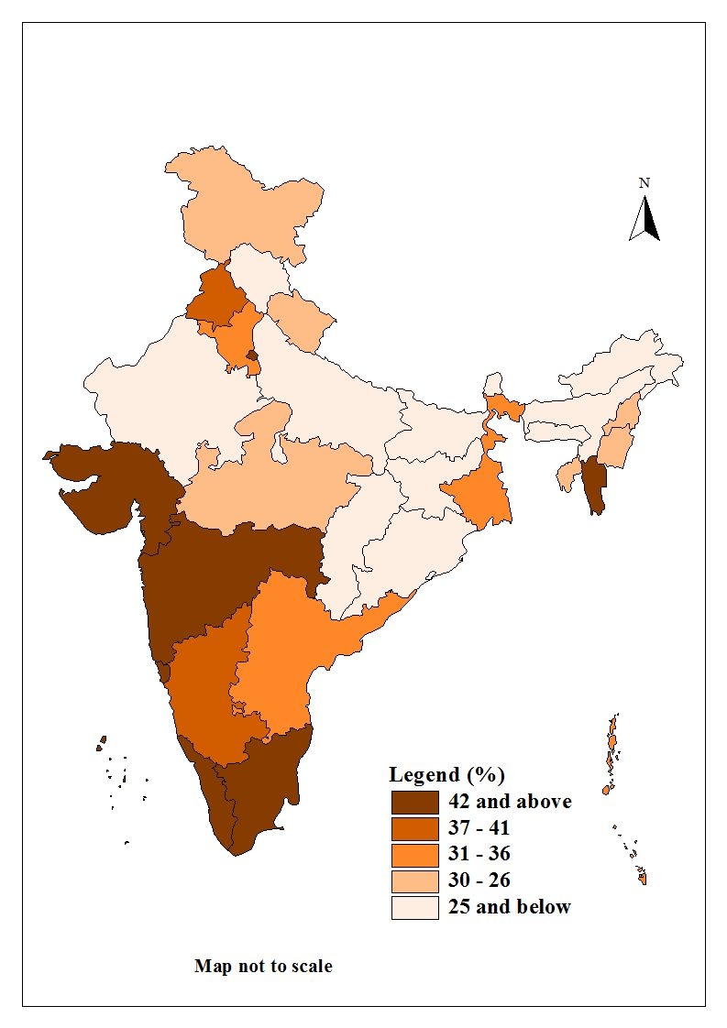
Fig 1: Levels of Urbanisation, India, 2011

Although reversal in the declining trend in urban population growth rate at the national level is a major feature of urbanisation revealed by 2011 Census, there are only 15 states and UTs which show increased urban population growth rate during 2001-2011 compared to 1991-2001. Among them Kerala, Andhra Pradesh, Karnataka, Gujarat, West Bengal, Bihar, Jharkhand, Chhattisgarh and Uttarkhand are the major states. A very high urban population growth has occurred in the states of Kerala and Andhra Pradesh where urban population growth rate has increased to 6.5 percent per annum in Kerala and 3 percent per annum in Andhra Pradesh during 2001-11 compared to just about 1 percent per annum during 1991-2001. In both Kerala and Andhra Pradesh along with West Bengal and Gujarat, a large number of new towns have emerged as a result of rural-urban classification in 2011.

Table 5: Level of Urbanisation and Urban Growth in India and States, 2011
State/India | Urban Population  (in million) | % Urban | Average Annual Urban Growth Rate* | Average annual rural growth rate* | Urban-rural growth differentials*
Andhra Pradesh | 28.35 | 33.4 | 3.09 | 0.19 | 2.90
Arunanchal Pradesh | 0.31 | 22.6 | 3.18 | 2.07 | 1.01
Assam | 4.38 | 14.0 | 2.43 | 1.41 | 1.02
Bihar | 11.72 | 11.30 | 3.01 | 2.15 | 0.86
Chhattisgarh | 5.93 | 23.2 | 3.49 | 1.65 | 2.84
Goa | 0.90 906,309 | 62.1 | 3.01 | -2.02 | 5.03
Gujarat | 25.71 25,712,811 | 42.5 | 3.06 | 0.89 | 2.17
Haryana | 8.82 8,821,588 | 34.7 | 3.66 | 0.99 | 2.67
Himachal Pradesh  PradeshPradesh | 0.68 688,704 | 10.0 | 1.45 | 1.17 | 0.28
Jammu & Kashmir | 3.41 3,414,106 | 27.2 | 3.04 | 1.88 | 1.16
Jharkhand | 7.92 7,929,292 | 24.0 | 2.79 | 1.79 | 1.00
Karnataka | 23.57 23,578,175 | 38.5 | 2.72 | 0.75 | 1.97
Kerala | 15.93 15,932,171 | 47.7 | 6.56 | -3.00 | 9.56
Madhya Pradesh | 20.05 20,059,666 | 27.6 | 2.28 | 1.70 | 0.58
Maharashtra | 50.82 50,827,531 | 45.2 | 2.12 | 0.99 | 1.13
Manipur | 0.82 | 30.2 | 3.55 | 0.43 | 3.12
Meghalaya | 0.59  595,036 | 20.0 | 2.7 | 2.45 | 0.25
Mizoram | 0.56 561,977 | 51.5 | 2.42 | 1.61 | 0.81
Nagaland | 0.57 573,741 | 28.9 | 5.15 | -1.5 | 6.65
Orissa | 6.99 6,996,124 | 16.6 | 2.37 | 1.13 | 1.24
Punjab | 10.38 10,387,436 | 37.4 | 2.28 | 0.76 | 0.52
Rajasthan | 17.08 17,080,776 | 22.8 | 2.56 | 1.74 | 0.82
Sikkim | 0.15 151,726 | 24.9 | 9.29 | -0.52 | 9.81
Tamil Nadu | 34.94 34,949,729 | 48.4 | 2.4 | 0.64 | 1.76
Tripura | 0.96 960,981 | 26.1 | 5.65 | 0.23 | 5.42
Uttar Pradesh | 44.47 44,470,455 | 22.2 | 2.52 | 1.64 | 0.88
Uttarakhand | 3.09 3,091,169 | 30.5 | 3.49 | 1.07 | 2.42
West Bengal | 29.13 29,134,060 | 31.8 | 2.61 | 0.74 | 1.87
Andaman & Nicobar Islands * | 0.13 135,533 | 35.6 | 1.53 | 0.18 | 1.35
Chandigarh | 1.02 1,025,682 | 97.2 | 1.3 | -11.55 | 12.85
Dadra & Nagar Haveli * | 0.15 159,829 | 46.6 | 11.52 | 0.73 | 10.79
Daman & Diu | 0.18 182,580 | 75.1 | 11.58 | -5.12 | 16.70
Delhi | 16.33 16,333,916 | 97.5 | 2.35 | -8.31 | 10.66
Lakshadweep | 0.05 50,308 | 78.0 | 6.23 | -8.68 | 14.91
Pondicherry | 0.85 850,123 | 68.3 | 2.71 | 1.91 | 0.80
India | 377.10 377,105,760 | 31.1 | 2.76 | 1.16 | 1.60
*average annual during 2001-2011

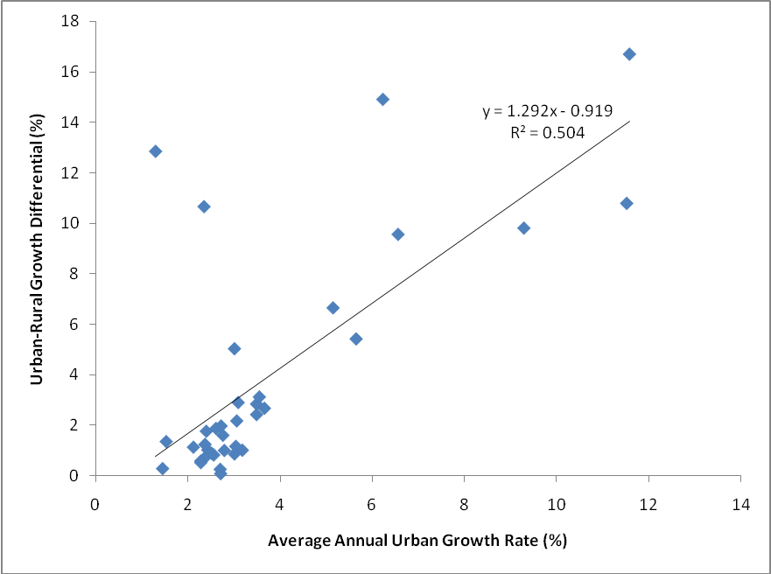
Fig 2: Relationship between urban growth rate and urban-rural growth differentials at state level, India, 2001-2011

As stated earlier, urbanization is the product of urban-rural growth differentials. Table 5 presents urban-rural growth differentials along with urban growth rate and level of urbanization (% urban). There exists a positive relationship between urban population growth rate and urban-rural growth differentials (see Fig 2) at the state level. Fig 3 further shows that the level of economic development contributes positively in widening urban-rural growth differentials and thus contributing to the speed of urbanization.

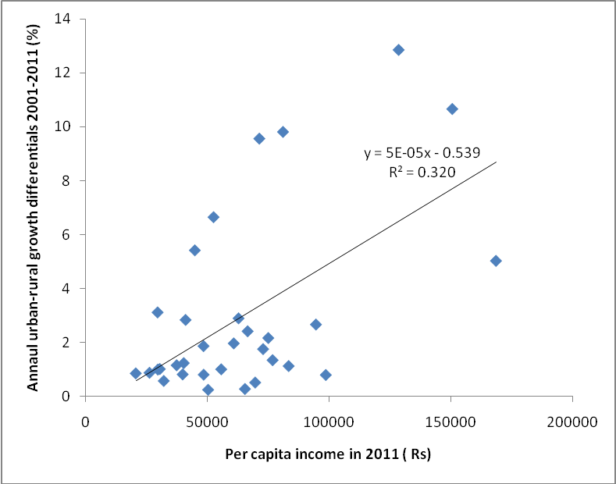
Fig 3: Per capita income and urban-rural growth differentials at state level, India

Various studies show that urbanization has been closely related to economic development, and is the single most important factor in the organization of production and access to services. Cities are considered to be engines of economic growth and temples of modern civilization. Thus to know how our cities are growing assumes enormous significance for understanding the problems of economy and society.

Size Class of Cities and Towns:

The size class of cities and towns are divided into six folds by Census of India namely more than 100,000, 99,999-50,000, 49,999-20,000, 19,999-10,000, 9,999-5,000, and less than 5000. The size class known as cities comprises places having a population of 100,000 and more, and the smallest category consists of tiny towns with a population less than 5000. For a meaningful comparison of the changes in urban population across size class of cities and towns, the towns comprising of population less than 20,000 are defined as small towns (Census of India 1991). Further, cities with population of a million and more deserve a special category in India’s urbanization because of their large size and economic dominance in the country. Such cities are called million plus or metropolitan cities. Table 6 presents the percentage distribution of urban population by size class of cities from 1901 to 2011. It may be seen from Table 6 that about five per cent of the population lived in million cities in 1901, with the figure rising close to 20 per cent in 1951 and to nearly 42.6 per cent by 2011 (see Fig 4 also). The number of million cities has also gone up from one in 1901 to 53 in 2011. Kolkata was the only city which fell into the million cities category at the beginning of the twentieth century, and then Mumbai joined the rank of million plus cities in 1911. For nearly four decades, there were only two million cities, and then Delhi, Chennai and Hyderabad joined the rank of million cities in 1951, increasing the total number of million cities to five. In 1981, the million cities numbered 12. By 1991, 11 more metro cities were added to the list, increasing the total number to 23. During the last decade 1991-2001, 12 more million plus cities have been added, followed by an addition of 18 more during 2001-2011 increasing the total number of million plus cities to 35 in 2001 and 53 in 2011 respectively. As a result, the concentration of urban population in million plus cities increased significantly in the last decade from about one-fourth in the 1970s to 1980s to more than two-fifths in the 2000s. Among the metropolitan cities, six cities that have a population of more than five million, namely Mumbai, Kolkata, Chennai, Delhi, Hyderabad and Bangalore, constitute one-fifth of the total urban population. When we look at all cities or territories with a population of 100,000 and more, one-fourth of the total urban population lived in cities in 1901. This went up to 45 per cent in 1951 and increased to the maximum of 68 per cent in 2001. In 2011, there the share of population in cities with population one lakh and more slightly declined from 68 per cent in 2001 to 65 per cent in 2011. Notwithstanding this slight decline, it is worthwhile to point out that the increasing concentration of population in cities, particularly in million plus cities, has been a striking feature of India’s urbanization during the last century. The increasing concentration of population in cities sometimes gives the impression that cities are growing much faster than small-and medium-sized towns; however, this is not true when the growth rates of population across size-class of cities and towns are considered. In fact, cities and towns are growing at about the same rate across size class of cities and towns (Bhagat 2004; Census of India 1991; Mohan & Pant 1982; Visaria 1997). However, results available from 2011 census are indicative that while urbanization in the country has speeded up, the metropolitan cities like Delhi, Kolkata, Hyderabad, Ahmadabad and Mumbai show decline in their growth rates (Kundu 2011). It is worthwhile to mention that while core areas (municipal areas) of the city has been showing a declining growth, the peripheral areas adjoining the main city has comparatively grown faster during the last decade surrounding many million plus cities. In this respect, the examples of cities like Navi Mumbai, Thane, Kalyan, Mira Bhayander in the Mumbai metropolitan region are noteworthy. Same is true for Gurgoan, Faridabad, Meerut, NOIDA around the National Capital Territory of Delhi. Thus, the nature of migration in the big metropolitan cities seems to have changed which need to be assessed in conjunction with the surrounding areas known as metropolitan region. The metropolitan cities have also very high density of population and it is likely to spill over to adjoining areas as a natural consequence. Thus, one of the important features of India’s urbanization seen from 2011 Census is not only faster urbanization, but also the faster urbanization has been possible due to the geographical expansion of urbanization and also through the emergence of new towns. On the other hand, vast areas still remain rural and providing urban facilities in rural areas (PURA) as proposed by our former President of India- A.P.J. Abdul Kalam in promoting India’s economic development still remains a challenge (Kalam 2003). Further, the civic conditions of many newly emerged as well as old small and medium towns are appallingly poor.

Table 6: Urban population by size class of cities and towns, India, 1901-2011

Census year | Million Cities (one million & above) | Cities (100 thousand to one million) | Large Towns (50 to 100 thousand) | Medium Towns (20 to 50 thousand) | Small Towns (less than 20 thousand)
1901 | 5.86 | 20.11 | 11.29 | 15.64 | 47.10
1911 | 10.89 | 16.74 | 10.51 | 16.40 | 45.46
1921 | 11.30 | 18.40 | 10.39 | 15.92 | 43.99
1931 | 10.34 | 20.86 | 11.65 | 16.80 | 40.35
1941 | 12.19 | 26.04 | 11.42 | 16.35 | 34.00
1951 | 19.07 | 25.57 | 9.96 | 15.72 | 29.69
1961 | 23.34 | 28.08 | 11.23 | 16.94 | 20.41
1971 | 26.02 | 31.22 | 10.92 | 16.01 | 15.83
1981 | 26.93 | 33.49 | 11.63 | 14.33 | 13.62
1991 | 33.18 | 32.01 | 10.95 | 13.19 | 10.66
2001 | 37.80 | 30.78 | 9.73 | 12.29 | 9.36
2011 | 42.62 | 23.09 | 9.33 | 12.78 | 11.75

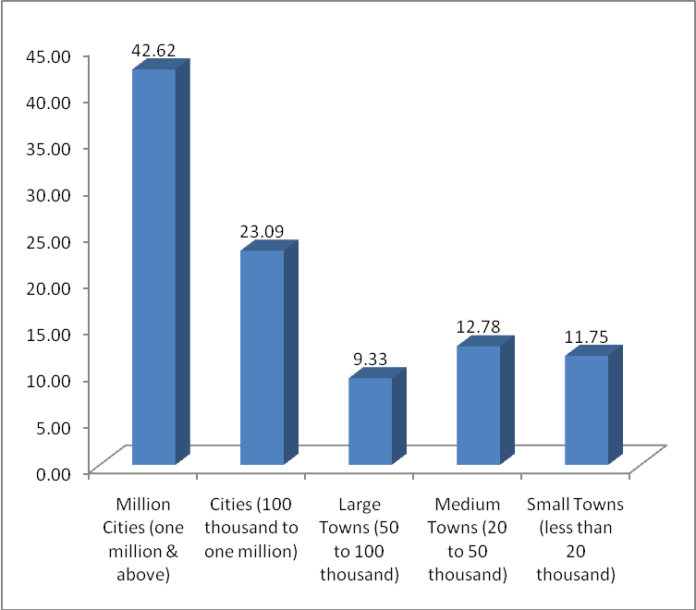

Fig 4: Percentage of urban population by size class of cities and towns, India, 2011

Access to Basic Amenities by Size Class of Cities/Towns:
According to 2011 Census, 55 per cent households in rural areas and 92 per cent of households in urban areas have access to electricity. So far the toilet facility is concerned, it was abysmally low in rural (30 per cent) compared to urban areas (81 per cent). Whereas about one-fifth of households do not have access to toilet facility in urban areas that means about 75 million urban populations have no access to toilet facility as per 2011 Census. Another aspect of sanitation closely associated with toilet facility is the wastewater outlet through the provision of drainage. The proportion of households either with open or closed drainage was 81 per cent in urban areas. Compared with toilet and drainage facility, access to drinking water provided either through tap or hand pumps was reported to be 74 per cent in rural areas compared to and 82 percent households in urban areas as per 2011 Census. Use of clean fuel is very important from health point of view. In rural areas, about one-tenth of households were found using LPG/PNG compared to three-fifths in the urban areas. This shows that a very high proportion (two-fifth) of households was still using polluting fuels which are not only hazardous for health but also contributes to greenhouse gases and global warming.
India’s urban population is distributed across 8000 odd towns and cities with different size, economic base and ability to generate resources from tax and non-tax sources. Class I cities (100 thousand and more) have higher employment in organized sector compared to small urban centres. In many small urban centres, a sizeable proportion of workforce is also dependent on agriculture. Thus, size as a measure of urban centres not only reflects population concentration but also their economic strength as well. It is expected that the provision of basic services is directly related to the size of urban centres. Table 7 presents basic amenities by size class of urban centres. It confirms that except toilet facility all other amenities like electricity, drainage, LPG/PNG etc increases with increasing size class of cities and towns.
Table 7: Percentage of households with access to selected basic amenities by size class of Urban centers, 2001 and 2011
India | Electricity |  | Toilet Facility |  | Drinking Water |  | LPG |  | Drainage
India | 2001 | 2011 | 2001 | 2011 | 2001 | 2011 | 2001 | 2011 | 2001 | 2011
Class-I
More than 5 million | 97.2 | 98.3 | 57.7 | 63.8 | 97.5 | 91.3 | 63.0 | 79.5 | 82.8 | 97.0
1 million- 5 million | 86.6 | 97.0 | 78.4 | 89.0 | 89.7 | 85.5 | 59.9 | 77.5 | 90.1 | 93.3
100 thousand-1 million | 80.9 | 93.7 | 72.9 | 83.5 | 85.1 | 83.2 | 50.5 | 68.4 | 78.4 | 84.9
Class-II
50-100 thousand | 77.7 | 91.8 | 66.4 | 77.1 | 81.8 | 84.0 | 43.7 | 63.9 | 73.3 | 80.1
Class-III
20-50 thousand | 76.6 | 88.5 | 62.5 | 75.4 | 78.3 | 75.4 | 35.6 | 53.8 | 67.3 | 71.8
Class-IV
10-20 thousand | 78.3 | 89.0 | 57.4 | 77.7 | 78.9 | 77.6 | 29.8 | 52.8 | 63.9 | 70.3
Class-V
5-10 thousand | 76.3 | 87.9 | 53.9 | 77.9 | 78.6 | 79.4 | 26.4 | 52.0 | 57.9 | 68.3
Class-VI
Less than 5 thousand | 77.9 | 88.6 | 62.5 | 75.9 | 71.3 | 81.0 | 26.6 | 51.1 | 50.8 | 64.2
Source: Census of India 2001 and 2011

About three-fourth of the households are covered by toilet facility among small towns (20 thousand and less) which even declines to 64 per cent among mega cities with population more than 5 million. In mega cities a high proportion of population living in slum areas that have either no access to toilet facility or have community toilets. The coverage of electricity varies from 88 per cent among small towns to 98 per cent among mega cities in 2011. The coverage of drinking water varied from about 80 per cent among small urban centres to 90 per cent among mega cities. While about one-fourth households are denied access to electricity, the same is about one-fifth for drinking water which rises to one-fourth in respect to toilet facility among small towns. Except tiny towns (population 10000 and below), the coverage of drinking water has declined across the size class of cities and town during 2001-2011. So far the access of LPG/PNG is concerned, the highest use of 80 per cent is found in mega cities compared to half of households in the small urban centres. While it is obvious that bigger cities in general have advantage in the use of clean fuel as LPG, but a significant proportion of residents across size class cities and towns also depend on kerosene, and the rest on other sources of fuel like coal, charcoal and wood as source of fuel which are sources of indoor pollution and ill health among a substantial urban population living in small and medium urban centres. There has been substantial increase (10 per cent more) in most of the basic services across size class of cities and towns except drinking water during 2001-2011. It appears that supply of drinking water is the most challenging in the urban areas. At the state level, the situation remains unchanged with regard to bigger cities, which show higher provision of the basic services compared to smaller urban centers. But the cities (1lakh and more) of poorer states like Bihar, Orissa, Jharkhand and Uttar Pradesh show much lower provision of basic services compared to cities of Punjab, Maharashtra, Gujarat and Karnataka. Thus, within same size class, inter-state disparities continue to manifest. On the other hand, while the households of the small cities and towns have low access to basic amenities, the poor households living in them are most severely denied the access to basic amenities (Bhagat 2013).

Conclusions and Policy Suggestions:

The declining trend in the urban population growth rate observed during 1980s and 1990s was reversed at the national level, and the level of urbanisation increased faster during 2001-2011. The urban population grew from 286 million in 2001 to 377 million in 2011- an increment of 91 million which is larger than the rural population increment of 90.5 million for the first time since independence. This paper presents an assessment of the emerging pattern of urbanization, its spatial pattern and the components of urban growth namely the contribution of natural increase, classification of rural into urban areas and the contribution of rural to urban migration. A substantial increase in urban population is contributed by net rural-urban classification and rural to urban migration. A huge number of new towns emerged during the last decade contributing significantly to the speeding up of urbanization which shows that the emerging form of urbanisation is spatially distributed in the form of large number of medium and small urban centres. On the other hand, although the contribution of natural increase in urban growth has declined in terms of proportions, its share in absolute numbers (about 40 million) continues to be huge due to large base of the urban population. This has implications not only for providing the increased urban infrastructure and civic amenities, but also of the reproductive and child health services in urban areas.
Urban areas face acute shortage of civic amenities. In order to deal with the rapid increase in urban population and faster urbanization, India has to push through several urban reforms and policy changes that have been initiated in the early 1990s. In India, urban development is a state subject; however Central Government used to provide guidelines and also promise increased funds through centrally initiated urban development programmes like Jawaharlal Nehru National Urban Renewal Mission (JNNURM) currently replaced by Smart Cities Mission and AMRUT (Altal Mission for Rejuvenation and Urban Transformation). Ironically, India has top down and project driven urban planning and development without regard for the local needs and short of integration in the urban and rural sectors. As the urban development is a state subject, an integrated urban development strategy will be helpful in developing medium and small urban centres. A synergy between the emerging pattern of urbanization, the constitutional mandate as embodied in 74th Amendment to the Constitution is the need of the hour.
Further there are multiple agencies responsible for the planning and governance in the metropolitan areas. For example, in Mumbai, there are a host of parastatal bodies like Mumbai Metropolitan Region Development Authority (MMRDA), Maharashtra Housing and Area Development Authority (MHADA), Slum Rehabilitation Authority (SRA), City and Industrial Development Corporation (CIDCO) which are responsible for various activities in the city apart from Municipal Corporation of Greater Mumbai (MCGM). Further, Mayor and elected councilors are not the decisive bodies in the civic administration compared to the role of Municipal Commissioner. Further in most cases, the state governments have not yet constituted the Metropolitan Planning Committee as envisaged in the 74th Amendment to the Constitution effected in 1992. There is also a lack of local democracy and empowerment of urban local bodies both politically and fiscally. Due to lack of local democracy, the city planning and development is left to the urban development authorities and parastatal bodies which mostly serve the business interest of builders, bankers, industrial houses and the politicians and elites. On the other hand, in the event of failures, migrants are blamed for the woes of the big cities. On the other hand, in small and medium towns, the conditions are even more deplorable in terms of access to basic amenities. A large number of small and medium towns lack capacity in planning and governance and many are still under the ambit of rural local bodies. A revamping of the municipal governance and their empowerment as per 74th amendment to the constitution is seriously needed to face the demographic challenges unleashed by faster urbanisation. The state governments are not willing to grant autonomy to the urban local bodies. On the other hand, any autonomy to the urban local bodies must also be accompanied by fiscal empowerment and technical and human resources support to those particularly falling under the category of small and medium size towns.
References

Ahluwalia, M. (2011). Prospects and Policy Challenges in the Twelfth Plan. Economic and Political Weekly, 46(21), pp. 88-105.

Bhagat R.B. (2002). Challenges of Rural-urban Classification for Decentralised Governance. Economic and Political Weekly. 37(25), pp. 2413-2416.
Bhagat, R. B. (2005). Rural-Urban Classification and Municipal Governance in India. Singapore Journal of Tropical Geography. 26(1), Pp. 61-74.

Bhagat, R.B. and Mohanty, S. (2009). Emerging Pattern of Urbanisation and Contribution of Migration in Urban Growth in India. Asian Population Studies. 5(1), pp. 5-20.

Bhagat, R. B. (2013). Urbanisation: Size Matters. Infochange Agenda, August 2013, http://infochangeindia.org/agenda/urbanisation/size-matters.html,.
Brockerhoff, M. (1999). Urban Growth in Developing Countries: A Review of Projections and Predictions. Population and Development Review. 25(4), pp.757-778.

Census of India (1991). Emerging Trends of Urbanisation in India. Occasional paper No. 1 of 1993, Office of the Registrar General and Census Commissioner, India, New Delhi.

Davis, K. (1961). Urbanisation in India: Past and Future. In: Roy Turner, ed., India’s Urban Future, Berkeley: University of California Press, pp. 3-26.
Kalam, Abdul, A.P.J. (2003). Ignited Minds: Understanding the Power within India. New Delhi: Penguin Books.
Kundu, A. (2003). Urbanisation and Urban Governance: Search for a Perspective beyond neo-Liberalism. Economic and Political Weekly. 38(29), pp. 3079-3087.

Kundu, A. (2007). Migration and Exclusionary Urban Growth in India. The 6th Dr C. Chandrasekaran Memorial Lecture, Mumbai: International Institute for Population Sciences.
Kundu, A (2011). Politics and Economics of Urban Growth. Economic and Political Weekly. 46(20), pp. 10-12.

Planning Commission, Govt. of India (2008). Eleventh five-year plan, Vol III: agriculture, rural development, industry, services and physical infrastructure. New Delhi: Oxford University Press.

Registrar General and Census Commissioner (2006). Population projections for India and states 2001-2026. Report of the Technical Group on Population Projections Constituted by National Population Commission, New Delhi, India: Office of the Registrar General and Census Commissioner.
State Statistical Bureau of China (1998). China statistical year book 1998. Beijing: China Statistics Press.
U.N. (2018). World urbanization prospects: The 2018 Revision. Population Division, New York: UN.
U.N. (2009). The world urbanization prospects: the 2009 revision. Department of Economic and Social Affairs, Population Division, New York: UN.
Zhu, Y. (2001). The Transformation of Township into Towns and Their Roles in China’s Urbanisation: Evidence from Fujian Province. In: The 24thIUSSP General Conference, Salvador-Bahia, Brazil, 18-24 August, 2001.

Zlotnik, H. (2002). Assessing Past Trends and Future Urbanisation Prospects: The Limitation of Available Data. In: International conference New Forms of Urbanisation: Conceptualising and Measuring Human Settlement in the Twenty-First Century, IUSSP Working Group on Urbanisation, Rockefeller Foundation Study and Conference Centre, Bellagio, Italy, 11-15 March.

